Simulating Literature through Randomization, Adjacency Prediction, and Spacial Memory Recognition

This study of simulating a variant of the card game Literature aims to minimize the moves necessary for team one (denoted T1) to obtain a half-suit. Player 0 (denoted P0) on T1 is the strategized player with the algorithm.

Benjamin Breer
Manoj Niverthi
What is Literature?
Literature, otherwise known as Canadian Fish, is a team-based card game with 2 teams, each with 3 players. This study is based on the 48-card variant of Literature in which the 8s and Jokers are removed from the traditional deck of cards; thus, each player is initially dealt 8 cards. For comprehensibility’s sake, Literature can be thought of as a sophisticated game of “Go Fish”. The objective is for one’s team to obtain the most half-suits as possible.
What are Half-Suits?
Removing the 8s out of the standard 52-card deck yields two ranges of cards, otherwise known as half-suits (HS). There are lower and upper half-suits, denoted LHS and UHS, respectively.
LHS: 2-3-4-5-6-7 (all suits)
UHS: 9-10-J-Q-K-A (all suits)
*Note: For the purposes of simulating, Jack, Queen, King, & Ace are denoted as 11, 12, 13, & 1, respectively.
DATA ANALYSIS
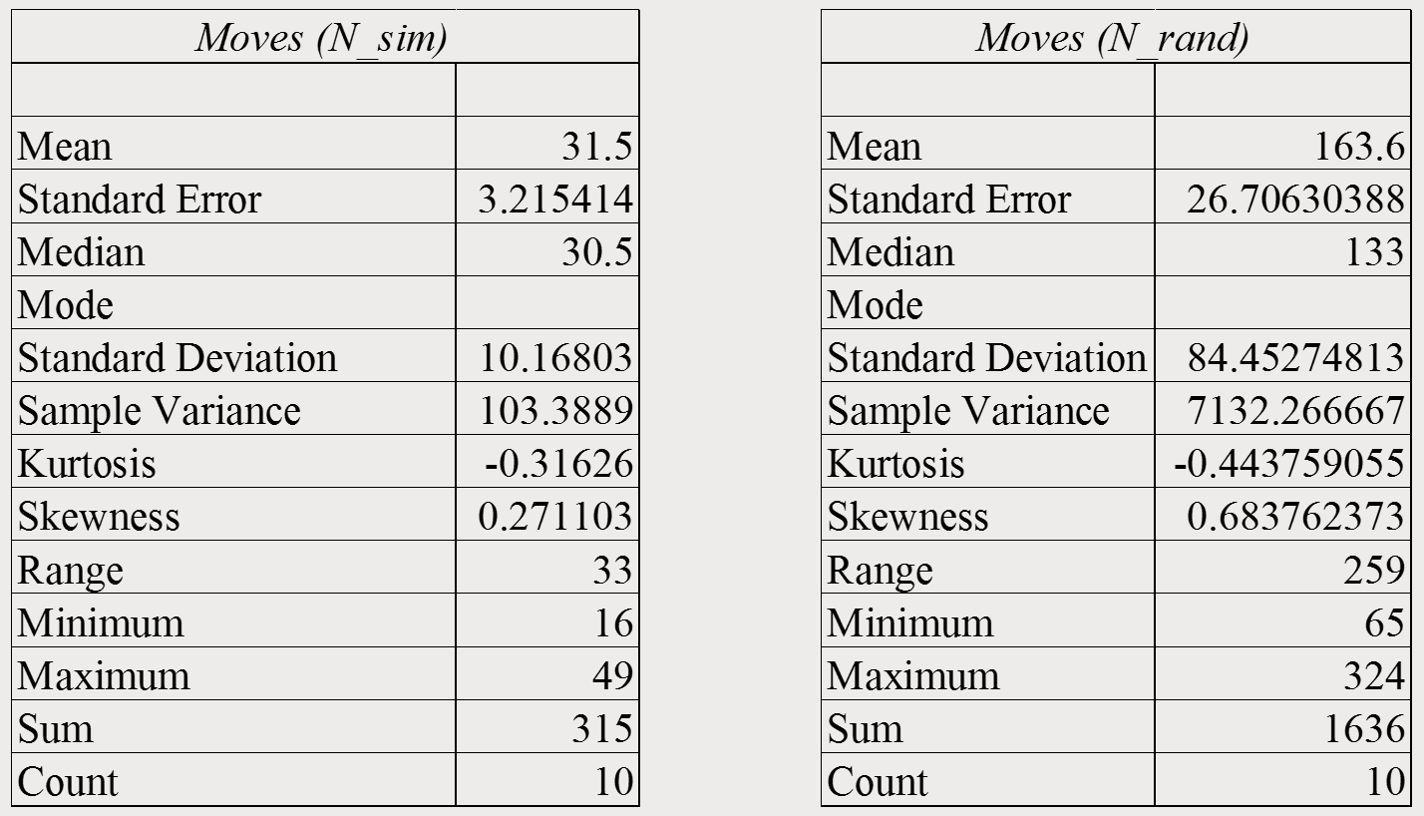
To provide a thorough analysis, a one-proportion, one-sided z-test was performed.
Null Hypothesis (H₀): p = 0.5
Alternative Hypothesis (H_{a}): $\hat{p}$ > p
- p = proportion of simulations where ${\overline{N}}_{sim}$< $\overline{N}$
CL = 0.99
α = 0.01
$\hat{p}$ = $\frac{6}{10}$ = 0.6
SE(p) =$\sqrt{\frac{p*q}{n}}=\sqrt{\frac{(0.5)(0.5)}{10}}$ = 0.025
P $\sim$ N(0.5, 0.025) = P($\hat{p}$ > 0.6) = P$\left(\text{z < }\left(\frac{\hat{p }- p}{SE(p)}\right)\right)$
= P$\left(\text{z < }\left(\frac{0.6 -0.5}{0.025}\right)\right)$= P(z < 4)
= normcdf(-$∞, 4, 31.5 , 0.025)$
= 1.489 x ${10}^{-84}$ $≈$ 0.000 => p-value
p-value < α
0.000 < 0.01
CONCLUSION
Because the p-value (0.000) is less than alpha (α = 0.01), we reject the null hypothesis (H₀) and suggest the alternative (H_{a}) that the proportion of simulations $\hat{p}$ where ${\overline{N}}_{sim}$< $\overline{N}$ is greater than p = 0.5. Through randomization, adjacency prediction, and SMR, the implemented algorithm can minimize the moves necessary to obtain one HS to 31.5 moves compared to the 163.6 moves necessary in a completely randomized setting.

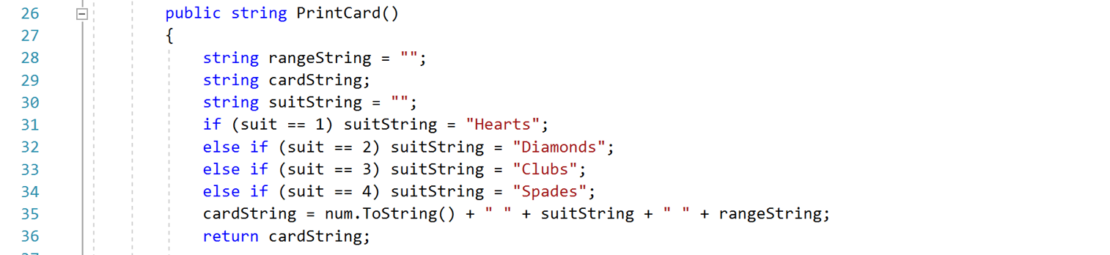
- Creating Deck Class & Players’ Hands
- Random selection of base & start cards
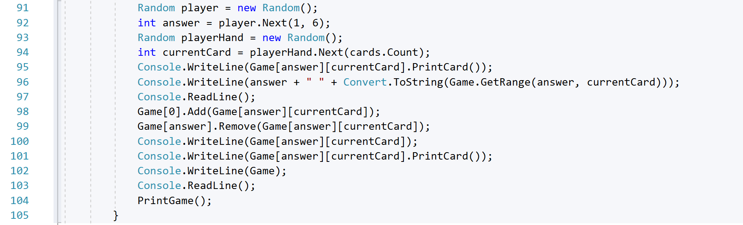
RESULTS

SIMULATIONS
A total of 10 algorithmic simulations were performed; an additional 10, completely randomized simulations were performed as a control to compare with the 10 strategized simulations (20 simulations in total).
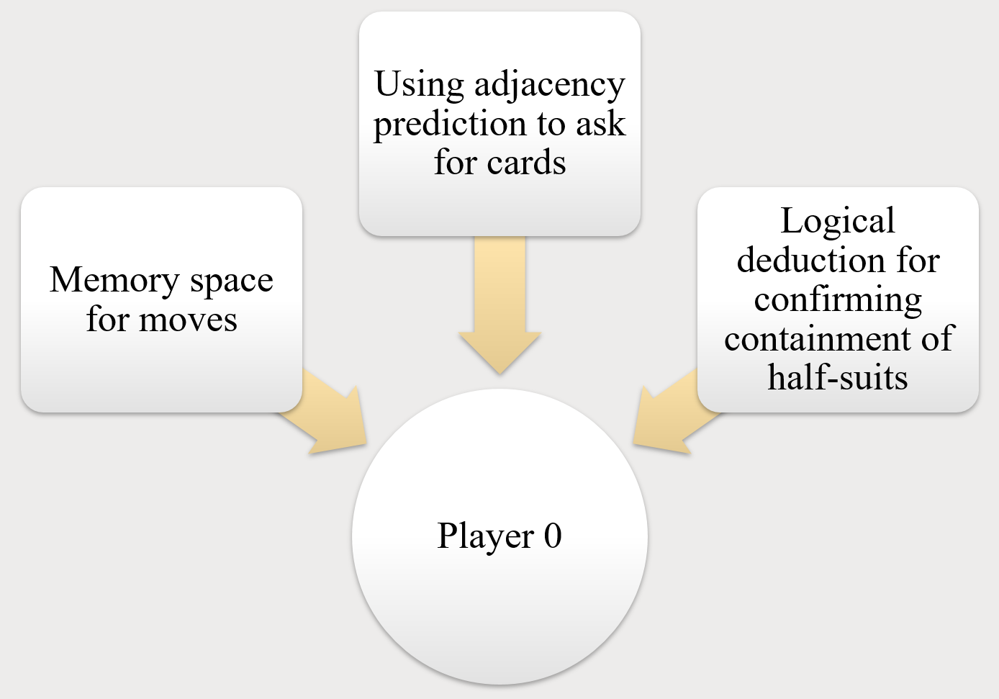
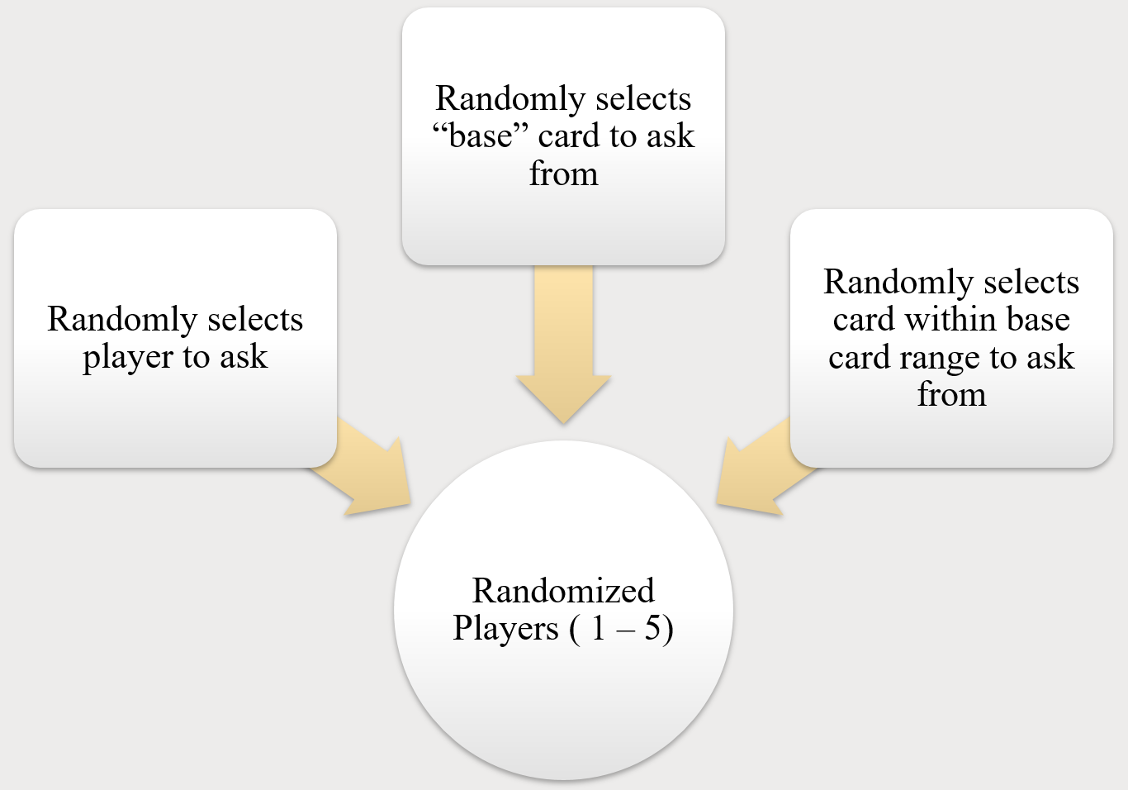
Creating a Customized Literature Deck
- Creating & initializing deck
- Creating Card Class
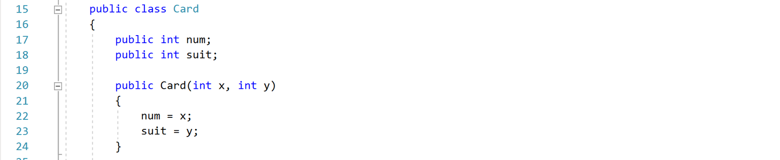

DISCUSSION
Game Structure and Set-Up
As aforementioned, there are two teams (T1 & T2) with three players each. For the purposes of this study, T1 contains P0 – P2 and T2 contains P3 – P5. Each player is initially dealt 8 cards. To build half-suits, players ask members of the opposing team for cards. Players must ask for cards which they do not currently have but that they have a card in a similar half-suit. Players cannot ask for cards outside the half-suits they currently have. If a player does not have the requested card, then they become the next player to go.
Declaring and Winning
The game of Literature concludes when all 8 half-suits have been declared. In this variant of Literature, there can be ties given there are an even number of half-suits to claim. Half-suits can be declared in two manners, through team-declaration or individual-declaration. For the purposes of producing simulations pertinent to the study’s focus, half-suits could only be declared by P0 (individual-declaration); however, P0 could declare a half-suit having only some, but not all, of the cards in the half-suit so long as P0 could, through adjacency prediction, utilization of memory spaces, and the implemented algorithm, logically deduce which other teammates had the remaining cards.
General Strategies
Claims should be made as quickly as possible if the location of cards are known completely. Avoid asking players who are known to have lots of cards in a half-suit one is attempting to claim. A “rapid-fire” session between players often divulges critical information about HS completion. Players can signal their teammates by asking for cards in a half-suit range which they do not have.

THE ALGORITHM
In order to minimize the moves necessary to obtain one half-suit, an algorithm was developed which employed randomization, adjacency prediction, and spacial memory recognition. Additionally, to properly analyze the algorithm’s effectiveness, a field of randomized players (P1 – P5) was created.
Randomization used to…
- Maintain uniformity for P1 – P5 card inquiries
- Select starting card for game to begin
- Aid in logical deduction for P0 to determine
locations of remaining cards
Adjacency Prediction is…
selecting cards to ask the next player based upon said card being located adjacently to the previously asked card. If the asked card is n, then adjacency prediction would result in P0 asking for the card n ± 1, a move denoted P0(n) n ± 1, P#.
Example: P2 has the 5 Clubs and asks P0 for 2 Clubs. P0 lacks 2 Clubs but has a card within the same HS range (e.g. 4 Clubs) and asks P2 within LHS(C) using adjacency prediction. In this example, the following moves would be played:
P2(5C) 2C, P0 : X *returns “null”
P0(4C) 3C, P2 *n – 1 used in this case
Spacial Memory Recognition
P0 utilizes the memory space of ongoing game to logically deduce which players have which cards.
SMR locates cards based on previous questions, players stripping cards from other players, and players receiving “null” as a response.
Example SMR from Simulation 9:
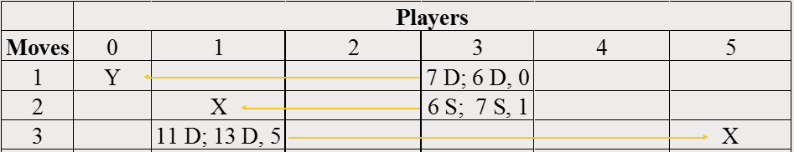
*Notation: CardInHand; CardAsked, PlayerToAsk

